Summary

1. Select a hyper-visor of your choice. ESXi… Hyper-V…VMWare Workstation… anything!
2. Requires 2 VMs, both windows and joined to the same Windows domain. I will be using **WSUSPRD01** and **DC01** for my example

Process:

1. Log into **WSUSPRD01** as the Domain Administrator account
2. Open **Server Manager**
3. Click on **Manage > Add Roles and Features**  
   Graphical user interface, text, application, chat or text message

   Description automatically generated
4. On the *Before You Begin* page, click on **Next**.  
   Graphical user interface, text, application

   Description automatically generated
5. On the *Select Installation Type* page, ensure **Role-based or feature-based installation** is selected and then click **Next**.  
     
   Graphical user interface, text, application

   Description automatically generated
6. Select the target server, which you are logged into. My server is **WSUSPRD01.ad.jakeyuhas.com**  
   Graphical user interface, text, application, email

   Description automatically generated
7. On the *Select Server Roles* page, scroll all the way to the bottom and check the box next to **Windows Server Update Services**  
     
   Graphical user interface, text, application

   Description automatically generated
8. A pop-up window will appear, just click **Add Features**  
     
   Graphical user interface, text, application

   Description automatically generated
9. Confirm that **Windows Server Update Services** is checked and then click **Next**  
     
   Graphical user interface, application

   Description automatically generated
10. On the *Select Features* page, just click **Next**.  
      
    Graphical user interface, text, application

    Description automatically generated  
    (Documentation continues on next page)
11. On the following page, click on **Next**.  
      
    Graphical user interface, text, application

    Description automatically generated
12. On the *Select Role Services* page, make sure **WID Connectivity** and **WSUS Services** are selected. Keep **SQL Server Connectivity** unchecked as we will be using the local WSUS database instead.   
      
    Graphical user interface, application

    Description automatically generated
13. On the *Content location selection* page, pause here, and open up File Explorer.
14. Navigate to C:\
15. Create a new folder called **WindowsUpdateRepository**  
      
    Graphical user interface, application, table, Excel

    Description automatically generated
16. Go back to the wizard in Server Manager
17. In the field put **C:\WindowsUpdatesRepository**Graphical user interface, text, application

    Description automatically generated
18. **Note: In a true production environment, you will want to create a separate hard drive for the virtual machine and give it about 100GB of free space (or more), and use that second hard drive to store only Windows Updates that the WSUS server will download. It should NEVER be on Drive C, as Windows Updates do take up a lot of space. If you ran out of space on Drive C… well… your virtual machine wouldn’t work anymore. If it ran out of space on Drive D, only WSUS stops working and your Windows OS is ok.**
19. Click **Next** after entering the file path of where you are going to store your Windows Updates.  
      
    Graphical user interface, text, application, Word

    Description automatically generated
20. On the *Web Server Role (IIS)* page, click **Next.**Graphical user interface, text, application, email

    Description automatically generated
21. On the *Select role services* page, just click **Next**. Note: As you may notice WSUS needs IIS to run so it is also installing IIS.  
      
    Graphical user interface, application

    Description automatically generated
22. On the *Confirm installation selections* page, click on **Install**, then go get some coffee.  
      
    Graphical user interface, text, application

    Description automatically generated
23. Once the installation has finished, you will need to click on the blue hyper-link that says **Launch Post-Installation Tasks**.  
      
    Graphical user interface, text, application

    Description automatically generated
24. Once you see the text change to *Configuration successfully completed*, you may close the wizard and Server Manager to get back to your normal desktop window.  
      
    Graphical user interface, text

    Description automatically generated with medium confidence
25. Click on the **Start Menu** button this will open the start menu
26. Find the **Windows Administrative Tools** folder and click the arrow to drill down the selections  
      
    Graphical user interface, application

    Description automatically generated
27. Scroll all the way to the bottom until you see **Windows Server Update Services**, go ahead and click on that.  
      
    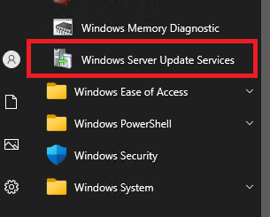
28. You will be presented with a new wizard screen.
29. On the *Before You Begin* page, go ahead and click **Next**.  
      
    Graphical user interface, text, application, email

    Description automatically generated
30. On the *Join the Microsoft Update Improvement Program* page, uncheck the box and click **Next**.  
      
    Graphical user interface, text, application

    Description automatically generated
31. On the *Choose Upstream Server* page, ensure that **Synchronize from Microsoft Update** is selected as this is the first WSUS server we are introducing to the environment and then click **Next**.  
      
    Note: You can have multiple WSUS servers in your environment. This is a good practice as you may have satellite offices that are connected to the main work campus. You don’t want all the devices at the satellite campus downloading from the internet as that can cause network congestion and slow download speeds. You want a second downstream WSUS server at the satellite office, that downloads the updates from the main work campus WSUS server, so that it only crosses the internet once. Then the satellite office devices can download directly from the WSUS server locally.  
      
    Graphical user interface, text, application, email

    Description automatically generated
32. On the *Specify Proxy Server* page, just click **Next**. We won’t be setting up a proxy server for synchronizing Windows updates in this lab.  
      
    Graphical user interface, application

    Description automatically generated
33. On the *Connect To Upstream Server* page, click on **Start Connecting**, this will begin synchronizing your Windows Update Server.  
      
    Graphical user interface, text, application

    Description automatically generated
34. **This may take a very long time, or at least a few minutes, please take a break here and eat something.**
35. When the synchronization is finished, the loading bar will turn fully green and the next button will become available. Click on **Next**.  
      
    Graphical user interface, text, application

    Description automatically generated
36. For the *Choose Languages* page, leave the defaults and then click **Next**.  
      
    Graphical user interface, text, application

    Description automatically generated
37. On the *Choose Products* page, check **All Products** and then **UNCHECK** it, so it deselects ALL of the updates. You don’t want to download and synchronize all products, that would take 182312312 light years.  
      
    Graphical user interface, text, email

    Description automatically generated
38. Since we are only using Windows Server 2022, we want to scroll down to **Windows Server operating system-21H2** as Windows Server 2022 is a reconfigured kernel of Windows 10 21H2. This title may change in the future!! Be aware.  
      
    Graphical user interface, text, application

    Description automatically generated
39. Once **Microsoft Server operating system-21H2** is selected, click on **Next**.
40. On the *Choose Classifications* page, ensure **Critical Updates**, **Definition Updates** and **Security Updates** are selected and then click **Next**.  
      
    Graphical user interface, text, application

    Description automatically generated
41. On the *Set Sync Schedule* page, keep the **Synchronize manually** option selected and click **Next**. Note: In a production environment, you would probably want to set this to 3 or 4AM daily.   
      
    Graphical user interface, text, application

    Description automatically generated
42. On the *Finished* page, make sure the checkbox next to **Begin Initial Synchronization**is selected and click **Next**.  
      
    Graphical user interface, text, application, email

    Description automatically generated
43. On the *What’s Next* page, click on **Finish**.  
      
    Graphical user interface, text, application

    Description automatically generated
44. This will open the **Update Services** console.
45. If you click on the **Synchronization** label, it will open the current synchronizations running.   
      
    Graphical user interface, text, application

    Description automatically generated
46. If you click on any of the syncrhonizations that are on-going, it will give you the status on the bottom half of your screen.  
      
    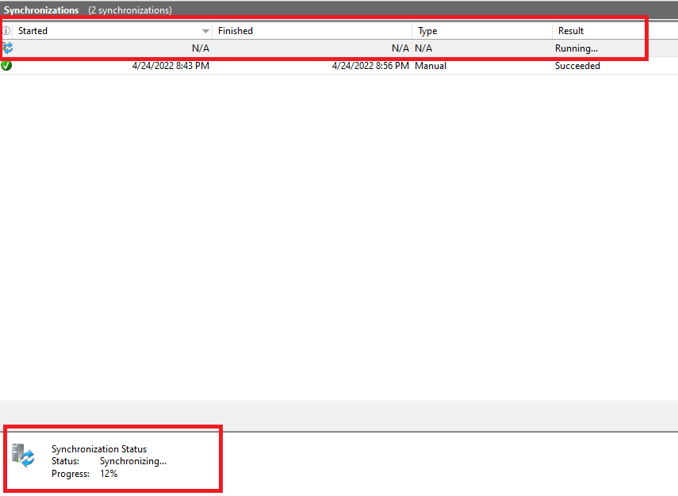
47. When you click on completed synchronizations, it will list some details regarding what the server found for new updates.  
      
    Text

    Description automatically generated
48. Since we have a synchronization running, we will let it run. In the meantime, we will perform Group Policy Configuration on **DC01**, we need to tell devices in the domain to look at **WSUSPRD01** for new Microsoft Windows updates instead of the internet.
49. Log into **DC01** as your Domain Administrator account
50. Open **Group Policy Management**, you can find this under **Windows Administrative Tools** in the Start Menu.
51. Once opened, navigate to your **Default Domain Policy** within the Group Policy Management console. (See picture below)  
      
    Graphical user interface, text, application, chat or text message

    Description automatically generated
52. Right-Click the Default Domain Policy and click **Edit**   
    Graphical user interface, text, application

    Description automatically generated
53. This will open the **Group Policy Management Editor**
54. In the navigation tree on the left, navigate to the following:
    1. **Computer Configuration**
    2. Click on the arrow next to **Policies**
    3. Click on the arrow next to **Administrative Templates: Policy Definitions (ADMX Files)**
    4. Click on the arrow next to **Windows Components**
    5. Scroll down and then click on **Windows Update**
55. You will see the right-screen populate with several policies to configure. They should all state **Not configured**.
56. Find the setting that states **Specify intranet Microsoft update service location**, right-click it and click on **Edit**  
      
    Graphical user interface, text, application

    Description automatically generated
57. On the *Specify intranet Microsoft update service location* page:
    1. Click on **Enabled**
    2. Set the intranet update service for detecting updates: [**https://wsusprd01.ad.jakeyuhas.com**](https://wsusprd01.ad.jakeyuhas.com)
    3. Set the intranet statistics server: [**https://wsusprd01.ad.jakeyuhas.com:8531**](https://wsusprd01.ad.jakeyuhas.com:8531)
    4. **NOTE: IF YOU ARE NOT USING ACTIVE DIRECTORY CERTIFICATE SERIVCES, CHANGE THE TWO TEXT FIELDS TO http://wsusprd01.ad.jakeyuhas.com:8530. In the previous lab we configured Active Directory Certificate Services and created a template to request a new certificate. If you have not finished this lab, use normal http with port 8530. If you HAVE completed this lab ignore this note.**Graphical user interface, text, application

       Description automatically generated **(Documentation continues on next page)**
58. Click on **Apply** and **OK** to commit the changes.
59. Note: If you wish to also configure automatic updates, there is a setting called **Configure Automatic Updates**. Right-Click and Edit the policy, set it to **Enable** and then click **Apply** and **OK**. With the default settings this will check for updates automatically every day at 3AM. This setting is seen enabled in production environments, but definitely not for a hospital. We like to control our updates and when they happen in a hospital setting. For a normal office, set it up for 3PM on a Friday and tell your employees to leave their PCs online when they leave for the day.
60. Log out of **DCPRD01** when you are finished.
61. Now that Group Policy is configured to our liking we now need to setup a new certificate on **WSUSPRD01** so that updates can be downloaded over https. These next steps require the previous lab to be completed.
62. Log back onto **WSUSPRD01** and Open the **Internet Information Services (IIS) Manager**, you can find this under the **Windows Administrative Tools** folder in the start menu.
63. Click on **WSUSPRD01** in the Navigation tree so that it is highlighted, this will change your center screen.  
      
    Graphical user interface, text, application, chat or text message

    Description automatically generated
64. On the center of the console, double-click on **Server Certificates**  
      
    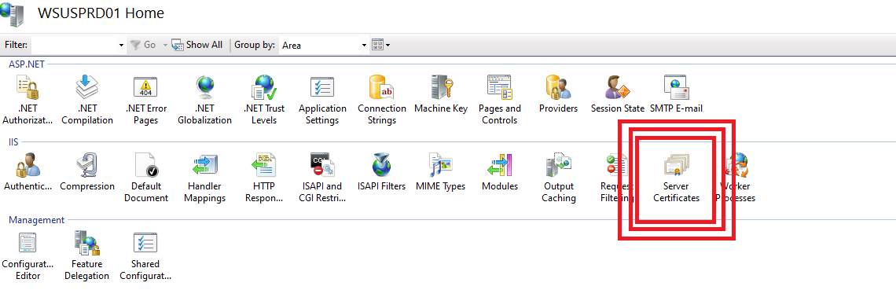
65. On the right-side of the console you will see **Actions**. Click on **Create Domain Certificate**  
      
    Graphical user interface, text, application, chat or text message

    Description automatically generated
66. This will open up a **Create Certificate** screen.. fill in the following information:
    1. Common Name: **wsusprd01.ad.jakeyuhas.com**
    2. Organization: **AD**
    3. Organizational Unit: **IT**
    4. City/Locality: **Worcester** (or whatever city you are in)
    5. State/Province: **MA** (or whatever state you are in)
    6. Country/Region: **US** (or whatever country you reside in)
    7. **Click Next**.  
         
       Graphical user interface, text, application

       Description automatically generated
67. On the next page, it will ask you to specify an online certification authority, click on the **Select** button on the right side of the window.  
      
    Graphical user interface, text, application

    Description automatically generated
68. You should see your Certificate Authority server listed on this screen, select it so that it is highlighted in blue and then click **OK**.  
      
    Graphical user interface, text, application

    Description automatically generated
69. Nice.
70. The **Specify Online Certification Authority** field should now be populated.
71. For **Friendly Name**, put in the full FQDN of the server, so mine would be **wsusprd01.ad.jakeyuhas.com**  
    Graphical user interface, text, application, email

    Description automatically generated
72. Click **Finish**.
73. The **WSUS** server should be immediately given a new certificate from the Root CA server. Now we need to bind this to the IIS website.  
      
    (Documentation continues on next page)
74. In the navigation pane on the left side of the console drill down **Sites** and then right-click on **WSUS Administration**. Click on **Edit Bindings**.  
      
    Graphical user interface, text, application, chat or text message

    Description automatically generated
75. In the Site Bindings menu, click on the type that says **HTTPS** and then click **EDIT**  
     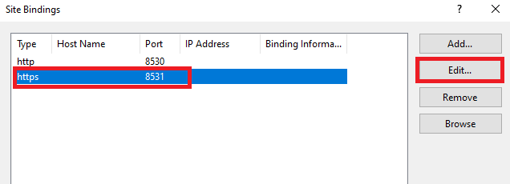
76. In the Edit Site Binding menu make sure the following is set:
    1. IP Address: **All unassigned**
    2. Port: **8531**
    3. Host Name: **KEEP THIS BLANK**
    4. SSL Certificate: **wsusprd01.ad.jakeyuhas.com**
    5. Then click **OK** after reviewing the screenshot below  
         
       Graphical user interface, text, application

       Description automatically generated
77. Then click on **Close** on the **Site Bindings** menu screen.
78. Then close the **IIS** manager window all together.
79. Open **Powershell** with **Run As Administrator  
      
    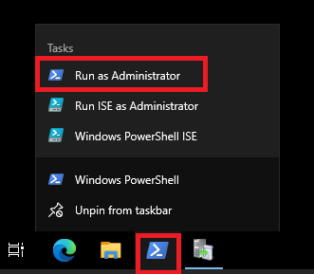**
80. In the powershell terminal, type **IISReset**. This will stop and then start the IIS services. We want to do this so that the services can properly bind the certificate we just assigned to port 8531.  
    Text

    Description automatically generated
81. **Note: If you had the Update Services console window open during this time, close it fully and then re-open it**.
82. Go back to the Windows Server Update Services console and navigate to **WSUSPRD01 > Computers >** **All Computers**
83. At the top of the middle pane in the console, set the **Status** to **Any**. You should begin to see other servers or workstations on your domain begin populating here.  
      
    Graphical user interface, application

    Description automatically generated  
      
    It looks like **DC02** checked in but not **DC01**.
84. If you have a server/workstation that is domain joined but cannot be detected on the WSUS server, log into that server/workstation and perform the following steps:  
    1. Open a **Powershell** terminal as **Administrator**
    2. Execute the command: **gpupdate /force**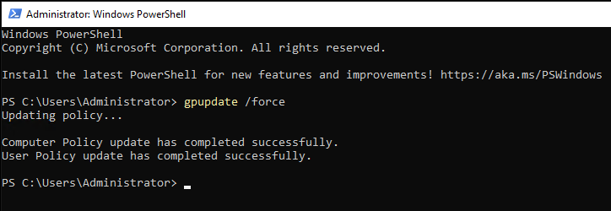
    3. Now that we forcefully refreshed the device’s group policy settings, we will now force it to check into the WSUS server. Write these commands down somewhere, they may save you some time someday.
    4. In the same elevated Powershell terminal execute: **wuauclt /detectnow**
    5. Then execute another command: **wuauclt /reportnow**Text

       Description automatically generated
85. Those commands should force the server/client to check in with the WSUS server. You can confirm this by returning to the WSUS server and clicking **Refresh**.
86. If the server is still not present, **Reboot the server.** Please note that sometimes it just takes a bit for servers to report into the WSUS server.
87. Since I have a server reporting into the WSUS server, I am going to approve the first round of updates.
88. On **WSUSPRD01**, right-click **All Computers** in the **Update Services** console and click **Add to Computer Group**.  
      
    Graphical user interface, application

    Description automatically generated
89. Name this group **Domain Controllers** and then click **Add**.  
      
    Graphical user interface, text, application

    Description automatically generated
90. The new group will now appear under **All Computers** in the navigation tree.  
      
    Graphical user interface, text, application, chat or text message

    Description automatically generated
91. Within **All Computers** right-click on **DC01** or **DC02** and click **Change Membership**  
      
    Graphical user interface, text, application

    Description automatically generated
92. In the **Set Computer Group Membership** pop-up, check the box next to **Domain Controllers** and click **OK**.  
      
    Graphical user interface, text, application

    Description automatically generated
93. This action just assigned **DC02** to the **Domain Controllers** Computer Group. This is how you can further organize to send update to a select group of computers, giving you as a System Administrator more granular control of deployment rings for monthly patching.
94. Navigate to **WSUSPRD01 > Updates > All Updates**, and sort the approval by **Unapproved** with the status set to **Failed Or Needed** and click refresh.  
      
    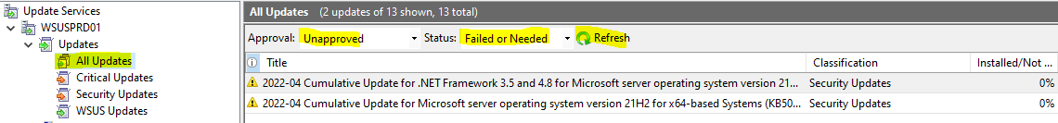
95. Click one of the updates in the center console so it is highlighted blue, then use key combination **CTRL+A** to highlight all of them.  
      
    Graphical user interface, text

    Description automatically generated with medium confidence
96. Right-click the highlighted stack of updates and click **Approve**.  
      
    Graphical user interface, text, application

    Description automatically generated
97. On this next page you can select if you want to **approve** the updates for certain computer groups or even all the computers that report to the WSUS server.  
      
    Table

    Description automatically generated
98. If you click on the  you can change the approval status of the given computer group or all.
99. For my example, I am going to approve the update for all servers that check into this WSUS server. Click on **Approved for Install** for **All Computers**.  
      
    Graphical user interface, application

    Description automatically generated
100. FYI, when you reach to step 100 in Word, the tabulation gets weird, so please excuse the text.
101. It should turn into a **Green Checkmark** and then you can click **OK**  
       
     Table

     Description automatically generated  
       
     (Documentation continues on next page)
102. Then the Approvals are complete it will show you the results.  
       
     Graphical user interface, text, application

     Description automatically generated
103. Click on **Close**, this should make the window disappear.
104. If you change the **Approval** to **Approved** at the top of the console and click **Refresh** it should now show the updates as approved. Keep in mind that these updates only apply to **Windows Server 2022**, but since we applied it to All computers, it means that any computer that is **Windows Server 2022** that is pointed to **WSUSPRD01** will download and install the listed updates from this WSUS server.
105. Log onto any server that has checked into the **WSUSPRD01** already, in my case that is **DC02** for me.
106. On **DC02**, I opened Windows Update and clicked on **Check For Updates**.  
       
     Graphical user interface, text, application, email

     Description automatically generated
107. **DC02** immediately began downloading and installing the updates from **WSUSPRD01**.  
       
     Graphical user interface, text, application, email

     Description automatically generated
108. That concludes this lab for the most part!
109. **Key Takeaways**
     1. Setting up WSUS is kind of time consuming, but once it is setup, it makes updating/patching servers easier. I would say the same for desktops/workstations but a large number of employees are now remote. Microsoft has released a new product called **Intune**, this is geared towards remote workers and updating/patching their devices using Microsoft Azure / Microsoft Cloud Services. **Intune** is a way better fit for managing remote devices.
     2. There are third party products that deliver updates to Windows Servers/Workstations such as:
        1. Ivanti Endpoint Manager (formerly called LANDesk)
        2. Patch by Ivanti
        3. PatchMyPC
        4. PDQ Deploy
        5. Automox
        6. ManageEngine
        7. Atera
     3. Microsoft Owned Patch Management Tools:
        1. Windows Server Update Services – For Servers and On-premises devices
        2. Windows Update For Business (going away soon)
        3. Windows Autopatch – For desktops/laptops
        4. Microsoft Intune – For Desktops/laptops/mobile devices that are on-premises or remote!
        5. SCCM / Config Manager – For Desktops and Servers, on-premises only.
        6. **MECM – Microsoft Endpoint Control Manager** – this is when **Intune** and **SCCM/Config Manager** are used together, it is referred to as MECM.
     4. Patching/Updating Servers and end user devices is easy, it’s reporting and validation that is a true challenge on the job for multiple organizations.
     5. If the traditional Windows Update isn’t working, you can visit [**https://www.catalog.update.microsoft.com/home.aspx**](https://www.catalog.update.microsoft.com/home.aspx)and download the manual windows update installer for almost any update. Monthly Cumulatives, .NET, Drivers etc., whatever Microsoft offers to WSUS, you can find it here in it’s own individual package for you to download.  
        1. Type: **YYYY-MM** to find the current month’s updates. So if I typed **2022-04**, that would be April of 2022 updates
     6. **Microsoft** releases their monthly public patches on every **2nd Tuesday** of the Month. They never miss a beat either.
     7. **Always** test the latest patches on a non-production or lab machine first to make sure it does not break your system entirely. Microsoft is known to release patches in the past that break the OS. For example, they had to pull back the updates to fix a bug back in **January 2022** that was causing Windows Server 2016 server’s that were Domain Controllers to be stuck in a reboot loop. We decided to not patch our Domain Controllers that month and waited for February’s updates 😊
     8. You should **ALWAYS** patch your servers monthly at the LATEST… and your servers should have anti-virus installed to ensure they are safe and secure if attackers were to ever attempt common exploits against Windows, web browsers (Google/Firefox/Edge), Office products etc. Patch EVERYTHING! (It’s literally my job at work so I say patch everything)